Student Name: Ben Sottile

Class and Section CS-210-02

Total Points (40 pts + 5 extra pts) __________________

**Due: Refer to Blackboard (Late homework submission is not acceptable! You must turn in your own work in blackboard!)**

#### **Project: Project: A Fun Game with Letters**

CS210 Introduction to Programming Principles

California Lutheran University

Problem Description:

Develop a fun game with Letters. Generate a random Letter from A-Z then ask the user to enter a word for a City, Food, a person Name, Country, and Animal which contains that Letter. Then calculate the total point and display their score. The total best score is 50 points.

1- 10 point if the first letter of each word matches

2- 5 point if the middle letter of each word matches

3- 2 point if the last letter of each word matches

Sample 1:

***Welcome to Fun Game with Letters****

Instructions: enter a City, Food, A Person Name, Country, and Animal that contains the given letter. 10 point if the first letter matches, 5 point if the middle letter matches, and 2 point if the last letter matches. Total score is 50 points.

Enter a City name that contains L: Los Angeles

Enter a Country that contains L: Libya

Enter a Name that contains L: Lorry

Enter an Animal that contains L: Lizard

Enter a Food that contains L: Lasagna

Congratulations you win the highest score 50.

Submit the following items:

1. Submit this world document with your answers before the due date.
2. Zip your project and submit it before the due date.
3. Analysis: (10 pts)

(Describe the program use cases. Write down the requirements for your code. Describe the stakeholders for your code. Describe what the SW should be able to do?)

Overview: Develop a fun game with Letters. Generate a random Letter from A-Z then ask the user to enter a word for a City, Food, a person Name, Country, and Animal which contains that Letter. Then calculate the total point and display their score. The total best score is 50 points.

Use cases:

To entertain people

To have a good time

To work on imagination.

To work on ones knowledge of words.

* 1. Requirements:
  2. The Software shall generate a random char.

The Software shall take Strings

The Sofware shall prompt the user to input(for a City, Food, a Name, Country, and Animal) that contains the random char

The Software shall be written in JAVA.

The Software shall include the scanner.util package to take in input

The Software shall not have any coding errors.

The Software will give the user points by the following criteria.

1. 10 points if the first letter of each word matches
2. 5 points if the middle letter of each word matches
3. 2 points if the last letter of each word matches

The Software shall be documented well.

The Software shall be readable.

The Software shall be testable.

The Software shall not crash.

1. Design: (10 pts)

(Describe the major steps for solving the problem. Only a flow chart will be acceptable.)

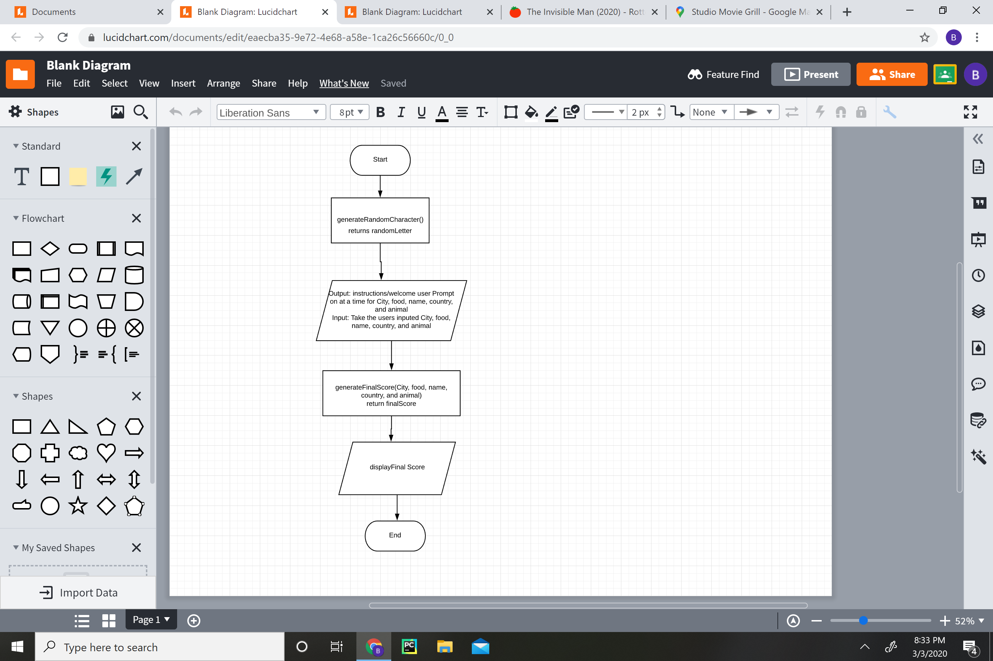

1. Coding: (10 pts)

(Copy and Paste Source Code here. Format your code using Courier 10pts. Screen shot of your code is also acceptable.)

**package** cs210;

**import** java.util.*;

**import** java.util.Timer;

**import** java.util.TimerTask;

**public** **abstract** **class** HW6 {

/*

* static TimerTask task = new TimerTask() { public void run() { if( .equals("")

* ) { System.out.println( "you input nothing." ); System.exit( 0 ); } } };

*/

/*Enter a City name that contains L: Los Angeles

Enter a Country that contains L: Libya

Enter a Name that contains L: Lorry

Enter an Animal that contains L: Lizard

Enter a Food that contains L: Lasagna

*/

// make syre one letter worlds srvie

**public** **static** **void** main(String[] args) {

Scanner newSc = **new** Scanner(System.***in***);

**char** randomLetter = *generateRandomLetter*();

**int** totalScore = 0 ;

System.***out***.println("Welcome to Ben Sottile's Speed Game!");

*instructionsGet*();

// boolean userAnswer = engageChronoRushMode();

// if(userAnswer = true) {

System.***out***.println("-----------Game Start-----------");

// Timer timer = new Timer();

System.***out***.println("Enter a City name that contains " + randomLetter +": ");

// timer.schedule( task, 10*1000 );

String city = newSc.nextLine();

// timer.cancel();

System.***out***.println("Enter a Country that contains " + randomLetter +": ");

String country = newSc.nextLine();

System.***out***.println("Enter a Name that contains " + randomLetter +": ");

String name = newSc.nextLine();

System.***out***.println("Enter a Animal that contains " + randomLetter +": ");

String animal = newSc.nextLine();

System.***out***.println("Enter a Food that contains " + randomLetter +": ");

String food = newSc.nextLine();

totalScore = *evaluateScore*(city, randomLetter, totalScore);

totalScore = *evaluateScore*(country, randomLetter, totalScore);

totalScore = *evaluateScore*(name, randomLetter,totalScore);

totalScore = *evaluateScore*(animal, randomLetter,totalScore);

totalScore = *evaluateScore*(food, randomLetter,totalScore);

System.***out***.println("Game Over: You Scored "+ totalScore + "/50!");

/*

* // }else { System.out.println("-----------Game Start-----------");

* System.out.println("Enter a City name that contains " + randomLetter +": ");

* String city = newSc.nextLine();

* System.out.println("Enter a Country that contains " + randomLetter +": ");

* String country = newSc.nextLine();

* System.out.println("Enter a Name that contains " + randomLetter +": ");

* String name = newSc.nextLine();

* System.out.println("Enter a Animal that contains " + randomLetter +": ");

* String animal = newSc.nextLine();

* System.out.println("Enter a Food that contains " + randomLetter +": ");

* String food = newSc.nextLine(); totalScore = evaluateScore(city,

* randomLetter, totalScore); totalScore = evaluateScore(country, randomLetter,

* totalScore); totalScore = evaluateScore(name, randomLetter,totalScore);

* totalScore = evaluateScore(animal, randomLetter,totalScore); totalScore =

* evaluateScore(food, randomLetter,totalScore);

* System.out.println("Game Over: You Scored "+ totalScore + "/50!");

*/

}

**public** **static** **boolean** engageChronoRushMode() {

**boolean** x = **true**;

**boolean** choice = **false**;

Scanner newSc = **new** Scanner(System.***in***);

**while**(**true**==x) {

System.***out***.println("Would you to play ChronoRush Mode? (You are only allowed 10 secounds to answer.) Type Yes or No");

String instrucInput = newSc.nextLine();

instrucInput = instrucInput.toLowerCase();

**if**(instrucInput.contains("yes")){

System.***out***.println("Hmm, its a challenge then!");

x = **false**;

choice = **true**;

**return** choice;

}**else** **if**(instrucInput.contains("no")) {

System.***out***.println("Loser!");

x = **false**;

choice = **false**;

**return** choice;

}**else** {

System.***out***.println("Huh?");

}

}

**return** choice;

}

**public** **static** **int** evaluateScore(String word, **char** randomLetter, **int** totalScore) {

**int** length = word.length();

word = word.toUpperCase();

**char** beginningLetter = word.charAt(0);

**char** middleLetter = word.charAt(length/2);

**char** endLetter = word.charAt(length - 1);

**if**( length < 2 ) {

**return** totalScore;

}

**if**(randomLetter == beginningLetter) {

totalScore += 10;

**return** totalScore;

}**else** **if**(randomLetter == middleLetter) {

totalScore += 5;

**return** totalScore;

}**else** **if**(randomLetter == endLetter) {

totalScore += 2;

**return** totalScore;

}**else** {

**return** totalScore ;

}

}

**public** **static** **char** generateRandomLetter() {

**int** randomNum = (**int**)((Math.*random*() * 26)+ 65);

**char** randomLetter = (**char**) randomNum;

**return** randomLetter;

}

**public** **static** **void** instructionsGet(){

Scanner newSc = **new** Scanner(System.***in***);

**boolean** x = **true**;

**while**(**true**==x) {

System.***out***.println("Would you like to hear the rules? Type Yes or No");

String instrucInput = newSc.nextLine();

instrucInput = instrucInput.toLowerCase();

**if**(instrucInput.contains("yes")){

System.***out***.println("Enter a word for a City, Food, a person Name, Country, and Animal ");

System.***out***.println("which contains the Letter displayed.");

x = **false**;

}**else** **if**(instrucInput.contains("no")) {

System.***out***.println("Alright, then let's get started!");

x = **false**;

}**else** {

System.***out***.println("Huh?");

}

}

}

}

1. Testing: (10 pts)

(Describe how you test this program, and attach your results screen shots here. For this homework at least 4 test cases are required (Be clear in your results.)

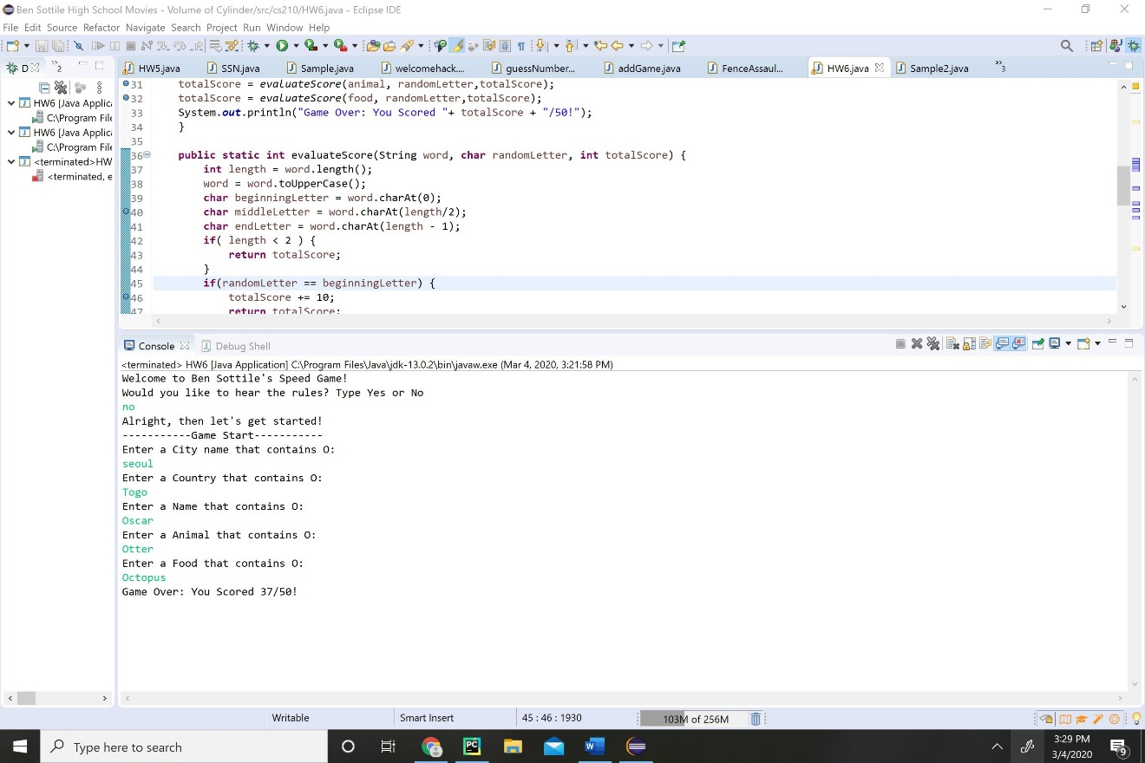

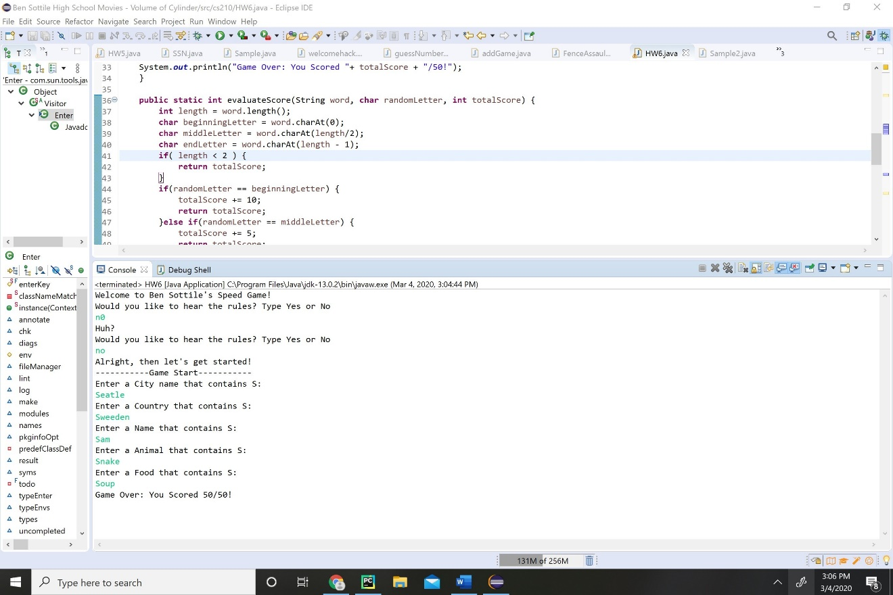

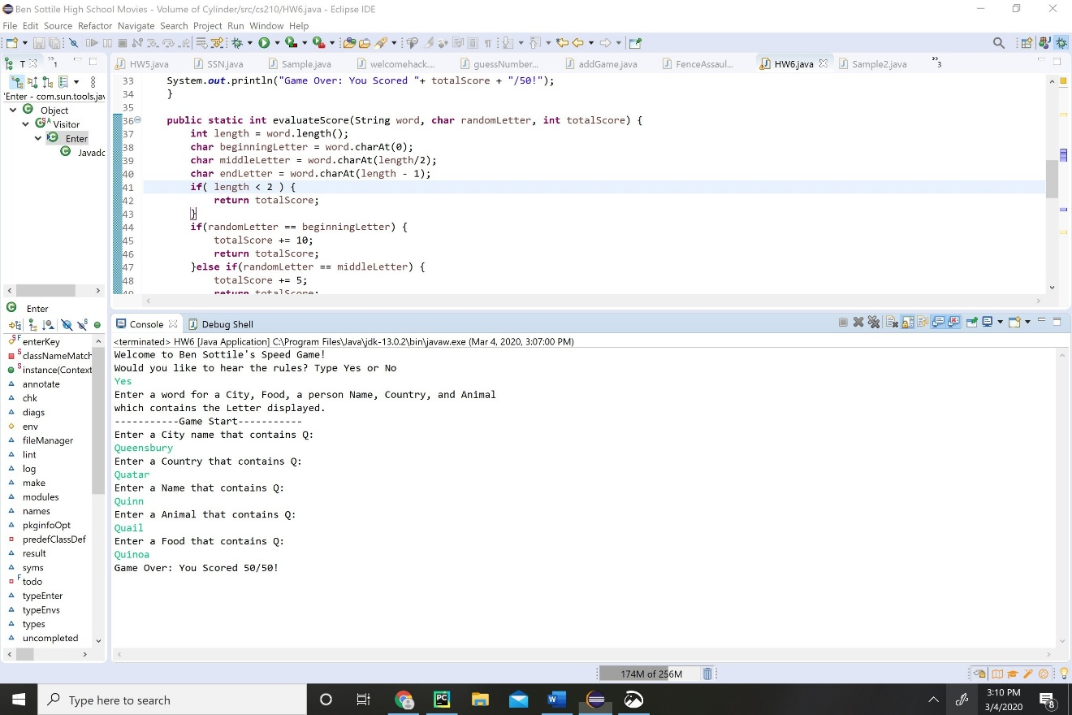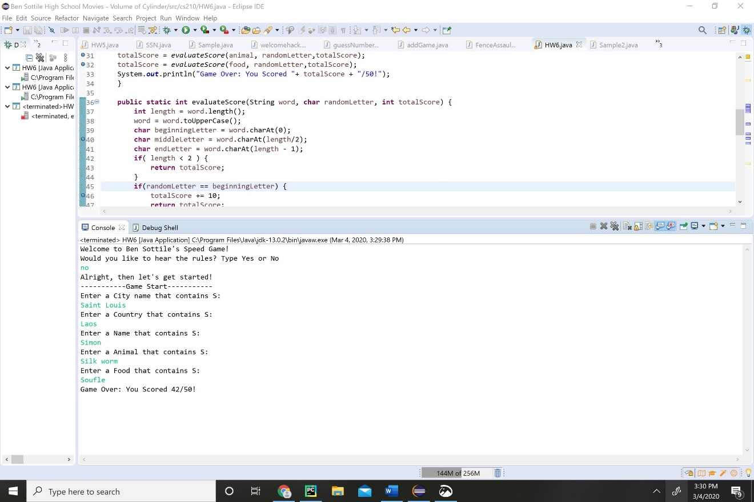

Extra point (5 pts): Your comment is very important to me, please answer these simple course evaluation questions so I can improve the class for the rest of semester. Welcome to add any extra suggestion or comments about the course.

1- What do you think about class materials and lectures?

|  |  |  |
| --- | --- | --- |
| Great | OK | Not Great |
| Image result for happy face emoji | Image result for ok face emoji |  |
|  |  |  |

Your comment:

The material and lectures are alright, can’t really complain

2- What do you think about the Pace of the course?

|  |  |  |
| --- | --- | --- |
| OK | Slow | Fast |
| Image result for happy face emoji | Image result for ok face emoji |  |
|  |  |  |

Your comment:

To me it feels just a tad slow but that might be because I’ve done Java before.

3- What do you think about the HomeWorks?

|  |  |  |
| --- | --- | --- |
| Ok | Easy | Hard |
| Image result for happy face emoji | Image result for ok face emoji |  |
|  |  |  |

Your comment: There fine challenges, that can be comfortably completed in the time limit. I would appreciate opportunity, to put our own flair on it.

4- What do you think about the Quizzes?

|  |  |  |
| --- | --- | --- |
| Ok | Easy | Hard |
| Image result for happy face emoji | Image result for ok face emoji |  |
|  |  |  |

Your comment:

The quiz focuses on a lot of syntax that is only partially if at all covered in the lectures. I’d prefer to do coding assessments instead, that test our understanding of core concepts on the fly.

5- What do you think about the class exercises?

|  |  |  |
| --- | --- | --- |
| Helpful | Ok | Not Helpful |
| Image result for happy face emoji | Image result for ok face emoji |  |
|  |  |  |

Your comment:

There alright they add some fun to the class but I’d appreciate if we would have time to code, before you show us the answer. I don’t think it is necessary to code with you only necessary to show us the answer everytime.

6- Your learning experience so far?

|  |  |  |
| --- | --- | --- |
| Learning a lot | Ok | Not Learning |
| Image result for happy face emoji | Image result for ok face emoji |  |
|  |  |  |

Your comment: Were just learning intro Java so its fine I guess.

7- Your overall experience about this class?

|  |  |  |
| --- | --- | --- |
| Happy | Ok | Not Happy |
| Image result for happy face emoji | Image result for ok face emoji |  |
|  |  |  |

Your comment:

It’s a good time, if you disregard what I’ve already mentioned.

8- Any topic that you like me to go over again in class?

No, I’m alright at the moment.

9- Would you like to have a one-one meeting? If yes, which day and hours works for you?

Not at the moment, if I do I’ll let you know.

10- Any additional comments or feedbacks.

Nothing else to report.